**AUTOMATED STUDENT ATTENDANCE MONITORING SYSTEM USING MULTIPLE FACE DETECTION AND RECOGNITION-AI**

**A.Yashwanth Balan1, R.Varun Pandi1,**

**S.Vasantha Kumar1,**

**N. Padma Priya2**

**1**Department of Computer Science and Engineering, SSM Institute of Engineering and Technology, Dindigul,

Tamil Nadu, India.

[yashwanthbalan75@gmail.com](mailto:yashwanthbalan75@gmail.com)

**2**Assistant Professor,

**2**Department of Computer Science and Engineering, SSM Institute of Engineering and Technology, Dindigul,

Tamil Nadu, India.

[priyapadma31@gmail.com](mailto:priyapadma31@gmail.com)

**ABSTRACT-**Tremendous research has been done on Facial Recognition by using various techniques and algorithms. In the human body, face is considered to be the distinctive part that identifies a person. Face recognition system can be built by making use of facial features and techniques. Taking or marking attendance is an important task in any organization. In educational institutions like college or schools, the teachers used to call out student’s name and used to mark their presence or absence in an attendance register. However, these traditional techniques of marking attendance are considered to be time taking and annoying. A better system which makes use of artificial intelligence can address this. The planned model makes use of a camera which supposed to take a photo as an input file, an algorithm for identification of face, then encoding and detecting the face captured in the image, marking the attendance in a excel sheet. Then the resultant images are stored in the database against an identifier. The features of the face can be extracted using Local Binary Pattern Histogram algorithm. The parameters radius, neighbours, gridx, gridy are considered. The algorithm trains the images and performs LBP operation and concluded with recognition of face. A test sample of images are taken as test images and these images are trained for detection and recognition of faces. The first functionality would be to capture the image and then detecting the faces and then to extract the features of images and storing it in the database.

**KEYWORDS-** Face Recognition, Deep Learning, Attendance, Biometric, Facial Features, Algorithms, Features, Datasets, Database.

1. **INTRODUCTION**

Human face plays -an important role in our day-to-day life mostly for identification of a person. Face recognition is a part of biometric identification that extracts the facial features of a face, and then stores it as a unique face print to uniquely recognize a person. Biometric face recognition technology has gained the attention of many researchers because of its wide application. Face recognition technology is better than other biometric based recognition techniques like finger-print, palm-print, iris because of its non-contact process. Recognition techniques using face recognition can also recognize a person from a distance, without any contact or interaction with person. The face recognition techniques are currently implemented in social media websites like Facebook, at the airports, railway stations. The, at crime investigations. Face recognition technique can also be used in crime reports, the captured photo can be stored in a database, and can be used to identify a person. Facebook uses the facial recognition technique for automating the process of tagging people. For face recognition we require large dataset and complex features to identify a person in all conditions like change of illumination, age, pose, etc. Recent researches show there is a betterment in facial recognition systems. In the last ten years there is huge development in recognition techniques.

Usually, in the classroom the attendance used to be taken by the teachers manually at the beginning and at the end of the class. The problem found with this approach was that it requires some time to take the attendance and also it was found that the manual process will have chances to make mistakes in most of the cases. In order to avoid such problems, Radio Frequency Identification technique came into existence in the past years. Even that system was a failure. So, we have come up with the concept of attendance management based on the recognition of face. The main idea of the system proposed here, is to allot attendance to the students using facial recognition-based techniques is to achieve fail proof attendance system. Face detection is one of the most common method used in many applications for identifying human faces in digital images or in an video. This technology is capable of predicting frontal or near-frontal faces in a captured photo, regardless of position and lighting conditions. The proposed system is a form of software based on biometric that maps an individual’s face features mathematically and then stores the data in the form of faceprint.

But currently most of the facial recognition techniques is able to work fine only if the number of people in one frame is very few and under controlled illumination, proper position of faces and clear images. For face recognition purpose, there is a need for large data sets and complex features to uniquely identify the different subjects by manipulating different obstacles like illumination, pose and aging. During the recent few years, a good improvement has been made in facial recognition systems. In comparison to the last decade, one can observe an enormous development in the world of face recognition. Currently, most of the facial recognition systems perform well with limited faces in the frame. Moreover, these methodologies have been tested under controlled lighting conditions, proper face poses and non- blurry images. The system that is proposed for face recognition in this paper for attendance system is able to recognize multiple faces in a frame without any control on illumination, position of face.

1. **LITERATURE SURVEY**

**[1]** K. The Shah (B) , D. Bhandare, S. Bhirud in paper[1], notes that the key results of the proposed scheme include: an integrated attendance system in real-time, strong model precision in identification of facial characteristics, avoidance of signature verification-related problems. They addressed in the paper about the accuracy obtained for the Haar model with attendance systems based on face recognition by making use of local binary pattern histogram (LBPH), K-nearest neighbour (KNN), principal component analysis (PCA) resulting in 93.1% of accuracy.

**[2]** Sudhir Bussa, Shruti Bharuka, Ananya Mani, Sakshi Kaushik in[2] notes that the face is the main feature of the human body that distinguishes a human. This suggested system can be applied by using the features of a face as biometric. He stated that the OpenCV based facial recognition approach has been proposed in this project.And it describes that this model incorporates a camera in the proposed framework which will capture the image that is inputted, an algorithm that detects the face from an image inputted, encoding and recognizing face, labeling the current time attendance to an excel sheet and translating it into a PDF. Using the faces of each particular student the training data base will be created. The clipped images are stored in a database with the corresponding unique identifiers. With the help of the LBPH algorithm, the features of the face are extracted.

**[3]** Rahul Ray , Faisal Khan , Harsh Sharma , Gaurav Kumar in [3] says that, their project aims at developing software that helps the organizations and institutions to monitor attendance of the present students in a smart and in an efficient manner. In this project some technologies used are facial recognition, python, opencv etc. The prime idea of the system proposed here is to capture each student's face and save it in the database to mark their attendance. The proposed system consists various processing phases they are: Capture Video, Separation of the Whole Video file into the Frames, Face Detection.

**[4]** Divya Pandey, Priyanka Pitale, Kusum Sharma in [4] discusses that in today’s evolving world, face recognition technologies have made several improvements. They said that the introduced system's role is to capture each student's face and then store the image for their attendance in the database. The student's face should be captured in such a way that it is necessary to detect all the features of the student's face. As the device records a video and the face is recognized and the database is modified by more processing steps, there is no need for the faculty to take part in the class manually. And they told that their software is designed using a python module named opencv.

**[5]** Mayank Srivastava, Amit Kumar, Aditya Dixit, Aman Kumar suggest combining face recognition technology with the OpenCV algorithm and building an attendance scheme. In this suggested method, three phases are involved.The initial step is the task of identifying and extracting the image of the face that is saved in an xml file and is used in next steps. The second step involves understanding and training the face image and thereby calculating the eigen vector and eigen value of an image. The concluding step is to identify images of the face stored in the xml file by comparing them.

**[6]** Samridhi Dev, Tushar Patnaik in[6] says that there are proxies in the conventional method of attendance and in existing biometric based systems. Therefore, to resolve all these issues, they presented this article. The suggested method uses Haar cascade classifiers, KNN, CNN, SVM, Generative adversarial networks, and filters like Gabor. The proposed method has measures that are below. They are building databases, enhancing images, detecting faces, extracting features, identifying faces, eliminating redundancies, producing reports. The goal of obtaining higher precision and lesser computational complexity is fulfilled by the proposed method. They mentioned that the planned scheme is economical and has reduced manual labor requirement. Precision is significantly enhanced using Gabor filters. Three algorithms have been used for face recognition, including KNN, CNN, and support vector machine, of which the KNN algorithm has been shown to have the highest accuracy of 99.27 percent. It has been found that CNN has low computational complexity. The SVM algorithm is not that efficient when compared to other algorithms\

**B. PROPOSED SYSTEM**

The development of new system contains various activities which satisfies the user requirements. With the advancement of the machine learning technology the machine automatically detects the attendance performance of the students and maintains a record of those collected data. From the perspective of manifold learning, our method can be regarded as performing a geometry-aware dimensionality reduction from the original HAAR cascade algorithm manifold to a lower-dimensional, more discriminative manifold where more favourable classification can be achieved. And also provide neural network algorithm to classify faces with improved accuracy in attendance system. Finally provide SMS and Email based alert system with real time implementation. The task of the proposed system is to capture face of each student and to store it in the database for their attendance.

**C. SYSTEM REQUIREMENT:**

**a) HARDWARE REQUIREMENTS:**

* Processor : Intel Core processor
* RAM : 4 GB
* Hard disk : 500 MB to 1 TB
* Compact Disk : 650 Mb>
* Keyboard : Standard keyboard
* Monitor : 15-inch color monitor
* Camera : System Camera (Single Shot)
* For Multiple Face Detection High Quality Camera is Required (Kinect Camera)

**b) SOFTWARE REQUIREMENTS:**

* Operating system : Windows OS
* Front End :PYTHON LANGUAGE
* Back End :WAMP Server-phpMyAdmin Server
* IDE :PyCharm Community/ Python IDE
* Application :Windows application.

1. **IMPLEMENTATION**

**A. MODULE DESCRIPTION**

A "module" in an open-project is a high-level description of a functional area, consisting of a group of [processes](http://www.project-open.com/en/list-processes) describing the functionality of the module and a group of [packages](http://www.project-open.com/en/list-packages) implementing the functionality.

**a) FACE IMAGE ACQUISITION:**

A  face recognition system is a [computer application](https://en.wikipedia.org/wiki/Application_software) capable of [identifying](https://en.wikipedia.org/wiki/Identification_of_human_individuals) or [verifying](https://en.wikipedia.org/wiki/Authentication) a person from a [digital image](https://en.wikipedia.org/wiki/Digital_image) or a [video frame](https://en.wikipedia.org/wiki/Film_frame) from a [video](https://en.wikipedia.org/wiki/Video) source. One of the ways to do this is by comparing selected [facial features](https://en.wikipedia.org/wiki/Face) from the image and a face [database](https://en.wikipedia.org/wiki/Database_management_system). Recognition algorithms can be divided into two main approaches, geometric, which look at distinguishing features, or photometric, which is a statistical approach that distills an image into values and compares the values with templates to eliminate variances. Face recognition from image or video is a popular topic in biometrics research. Face recognition is an interesting and successful application of Pattern recognition and Image analysis. Facial images are essential for intelligent vision-based human computer interaction. Face processing is based on the fact that the information about a user’s identity can be extracted from the images and the computers can act accordingly. Many public places usually have surveillance cameras for video capture and these cameras have their significant value for security purpose. It is widely acknowledged that the face recognition has played an important role in surveillance system as it doesn’t need the object’s cooperation. In this module, admin can train multiple faces. Face may be captured through web cameras or uploaded as still pictures. In this image, user faces without occlusion, straight pose and normal light conditions.

**b) FEATURES EXTRACTION:**

Applying human visual property in the recognition of faces, people can identify face from very far distance, even the details are vague. That means the symmetry characteristic is enough to be recognized. Human face is made up of eyes, nose, mouth and chin etc. There are differences in shape, size and structure of those organs, so the faces are differing in thousands of ways, and we can describe them with the shape and structure of the organs so as to recognize them. One common method is to extract the shape of the eyes, nose, mouth and chin, and then distinguish the faces by distance and scale of those organs. The other method is to use deformable model to describe the shape of the organs on face subtly. This module, facial features are extracted. And constructed as feature vectors. Facial features include nose part, eye parts and lip part. These values are stored is in the form of matrix.

**c) REGISTER THE FACE:**

Face registration is the process of transforming different sets of data into one coordinate system. Facial features are stored with labels. Image registration or image alignment algorithms can be classified into intensity-based and feature-based.  Face recognition systems identify people by their face images. Face recognition systems establish the presence of an authorized person rather than just checking whether a valid identification (ID) or key is being used or whether the user knows the secret personal identification numbers (Pins) or passwords. One of the images is referred to as the reference or source and the others are respectively referred to as the target, sensed or subject images. Image registration involves spatially registering the target image(s) to align with the reference image. Intensity-based methods compare intensity patterns in images via correlation metrics, while feature-based methods find correspondence between image features such as points, lines, and contours. Intensity-based methods register entire images or sub-images. Labelling the faces using their names. Face image registration is the process of transforming different sets of data into one coordinate system. Data may be multiple photographs, data from different sensors, times, depths, or viewpoints.

**d) FACE CLASSIFICATION:**

Face recognition have gained a great deal of popularity because of the wide range of applications such as in entertainment, smart cards, information security, law enforcement, and surveillance. It is a relevant subject in pattern recognition, computer vision, and image processing. Face identification is a one-to-many matching process that compares a query face image against all the template images in a face database to determine the identity of the query face.This module is known as login phase or testing phase. Input is in the form of real time video capturing. Video images are splited into still images. Face detection is done in the process. Matching the features using CNN algorithm. The temporal information in video sequences enables the analysis of facial dynamic changes and its application as a biometric identifier for person recognition. We have utilize the human nature that human will have at least small amount of movements such as eyes blinking and/or mouth and face boundary movements. We can get this information easily because dealing with video sequence by which the whole sequence of the object's movements can be obtained.

**e) ALERT SYSTEM:**

In many of the access control applications, such as door open, the size of the group of people that need to be recognized is relatively small. The face pictures are also caught under natural conditions, such as frontal faces and indoor illumination. If the feature vectors are not matched means, considered as unknown faces. Create alert for unknown labelling. Finally provide alert, Email Alert to authorized person.

**IV. SYSTEM DESIGN**

**SYSTEM ARCHITECTURE:**

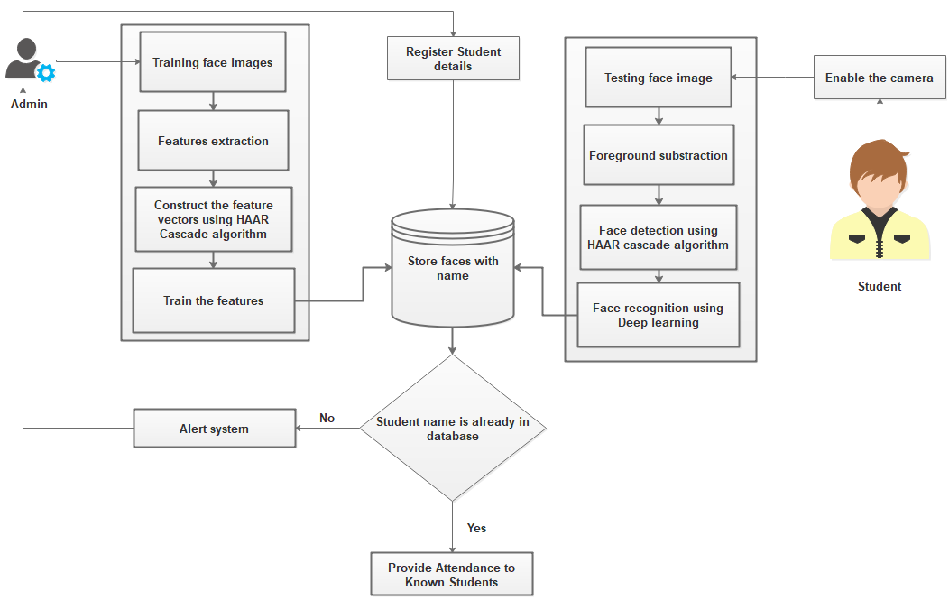

**Fig1. System Architecture**

**V. FUTURE WORKS**

In future work, we extend the framework to implement various algorithms to provide video face matching with improved accuracy rate. Videos provide an automatic and efficient way for feature extraction to reduce the features based on dimensionality reduction. In our further enhancement, we planned to implement a **Students Class Activity Monitoring System.** Activities like Listening the class, sleeping Etc.

**VII. CONCLUSION**

In this project, we reviewed face recognition technique for still images and video sequences. Most of these existing approaches need well-aligned face images and only perform either still image face recognition or video-to video match. They are not suitable for face recognition under surveillance scenarios because of the following reasons. So, we can propose a local facial feature-based framework for still image and video-based face recognition under surveillance conditions. This framework is generic to be capable of vide to face matching in real-time. While the training process uses static images, the recognition task is performed over video sequences. Our results show that higher recognition rates are obtained when we use video sequences rather than statics based on HAAR cascade and Convolutional Neural network algorithm. Evaluation of this approach is done for still image and video-based face recognition on real time image datasets with SMS alert system.

**REFERENCES**

**[1]** Shah K., Bhandare D., Bhirud S. (2021) Face Recognition-Based Automated Attendance System. In: Gupta D., Khanna A., Bhattacharyya S., Hassanien A.E., Anand S., Jaiswal A. (eds) International Conference on Innovative Computing and Communications. Advances in Intelligent Systems and Computing, vol 1165. Springer, Singapore. http://doi-org-443.webvpn.fjmu.edu.cn/10.1007/978-981-15-5113-0_79

**[2]** Sudhir Bussa , Ananya Mani , Shruti Bharuka , Sakshi Kaushik, 2020, Smart Attendance System using OPENCV based on Facial Recognition, INTERNATIONAL JOURNAL OF ENGINEERING RESEARCH & TECHNOLOGY (IJERT) Volume 09, Issue 03 (March 2020)

**[3]** Ray, Rahul. (2020). Class Attendance Portal (CAP) using Face recognition. International Journal for Research in Applied Science and Engineering Technology. 8. 1992-1996. 10.22214/ijraset.2020.30745.

**[4]** "Face Recognition Based Attendance System using Python", International Journal of Emerging Technologies and Innovative Research (www.jetir.org), ISSN:2349-5162, Vol.7, Issue 10, page no.547-551, October-2020, Available :http://www.jetir.org/papers/JETIR2010064.pdf **[5]** M. Srivastava, A. Kumar, A. Dixit and A. Kumar, "Real Time Attendance System Using Face Recognition Technique," 2020 International Conference on Power Electronics & IoT Applications in Renewable Energy and its Control (PARC), Mathura, Uttar Pradesh, India, 2020, pp. 370-373, doi: 10.1109/PARC49193.2020.236628.

**[6]** Anju V Das, Anjana Shyju, Thomas Varghese, Nisha Mohan P M, “Face Recognition Based Attendance System using machine learning algorithm” International Journal of Innovative Research in Technology (IJIRT), April 2021

**[7]** Saranya Babu, Rashmi R Rao, Shruddha, Sinchana Lahari, Varsha V Shetty,” An Exploratory Study on Face Recognition Based Attendance Monitoring System”, International Journal of Creative Research Thoughts (IJCRT), February 2021.

**[8]** Menezes, Angelo G., et al. "Automatic Attendance Management System based on Deep One-Shot Learning." 2020 International Conference on Systems, Signals and Image Processing (IWSSIP). IEEE, 2020.

**[9]** Chinimilli, Bharath Tej, et al. "Face Recognition based Attendance System using Haar Cascade and Local Binary Pattern Histogram Algorithm." 2020 4th International Conference on Trends in Electronics and Informatics (ICOEI)(48184). IEEE, 2020.

**[10]** Kumar, Praveen. "A Multiple Face Recognition System With Dlib’s Resnet Network Using Deep Metric Learning." Journal of Critical Reviews 7.6 (2020): 856-859.